Borja, Ellen Mae J.
BSIT-3C
Activity 3
Exercise 1: Print the squares of the numbers 1-20. Each number should be on a separate line, next to it the number 2 superscripted, an equal sign and the result.
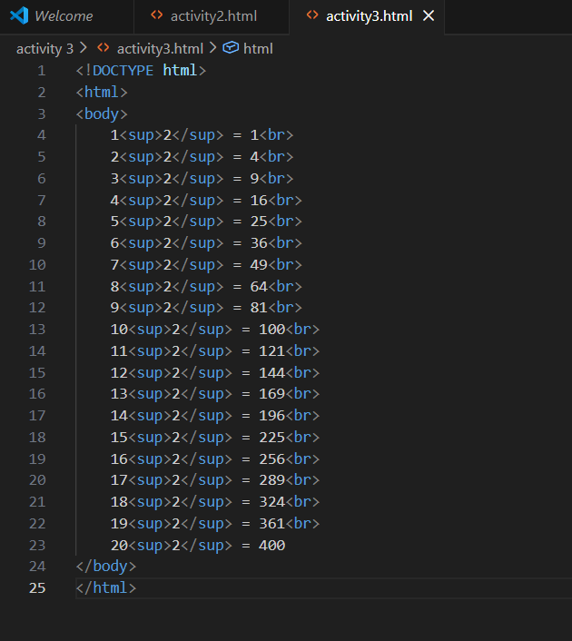
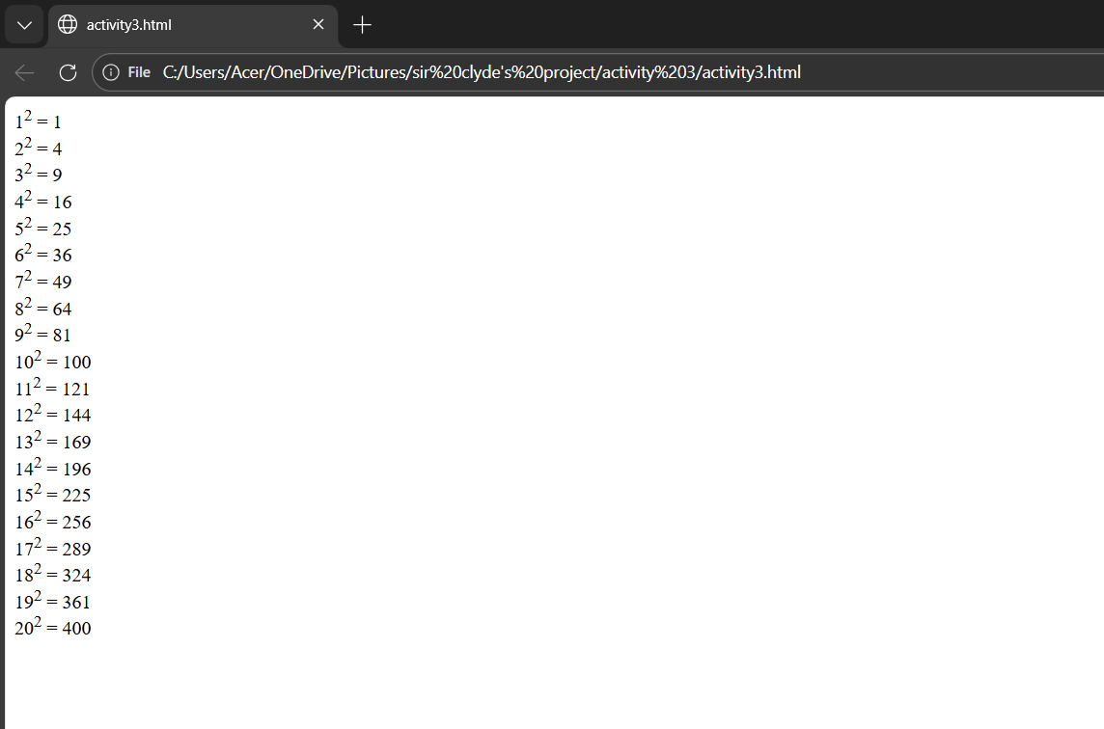

Exercise 2: Print 10 names with a line break between each name. The list should be alphabetized, and to do this place a subscripted number next to each name based on where it will go in the alphabetized list.
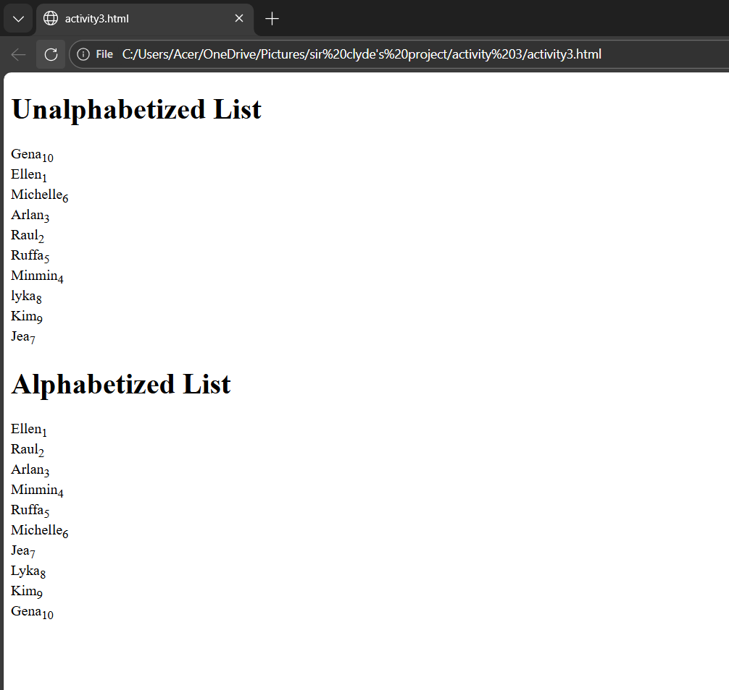
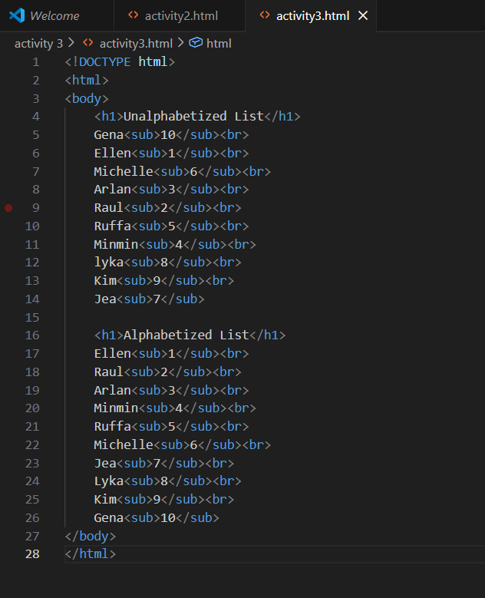

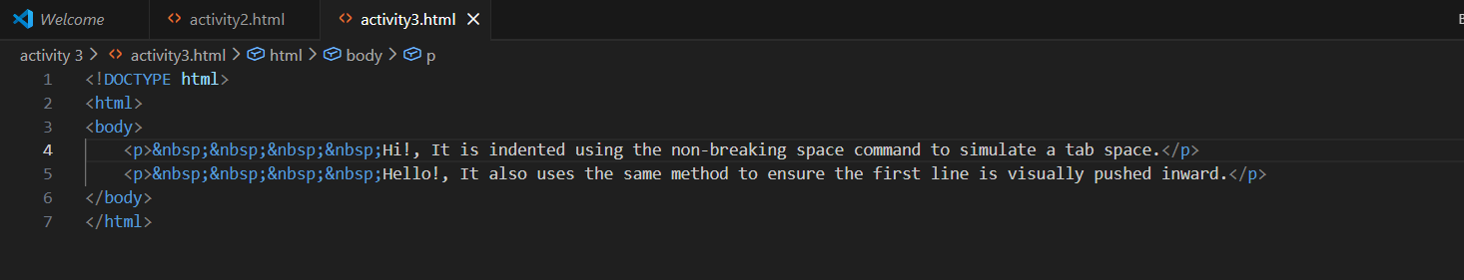
Exercise 3: Print two paragraphs that are both indented using &nbsp command.
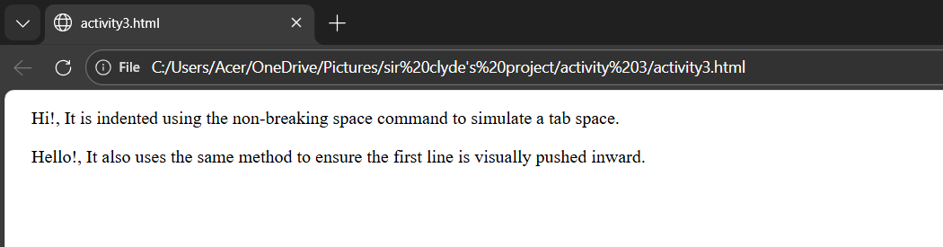

Exercise 4: Print two lists with any information you want. One list should be an ordered list, the other lists should be an unordered list.

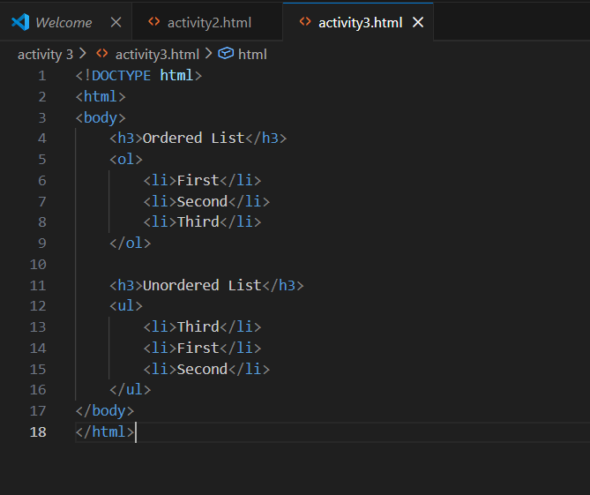
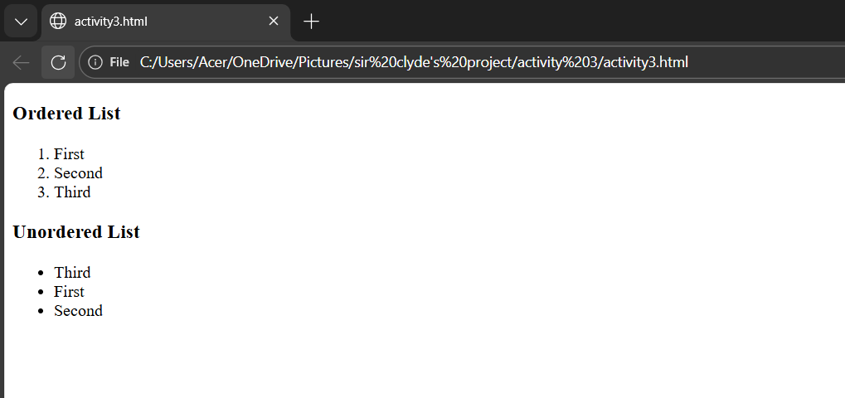

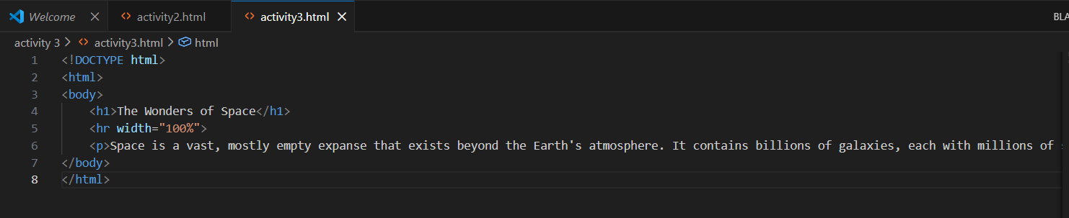
Exercise 5: Print an h1 level heading followed by a horizontal line whose width is 100%. Below the horizontal line print a paragraph relating to the text in the heading.
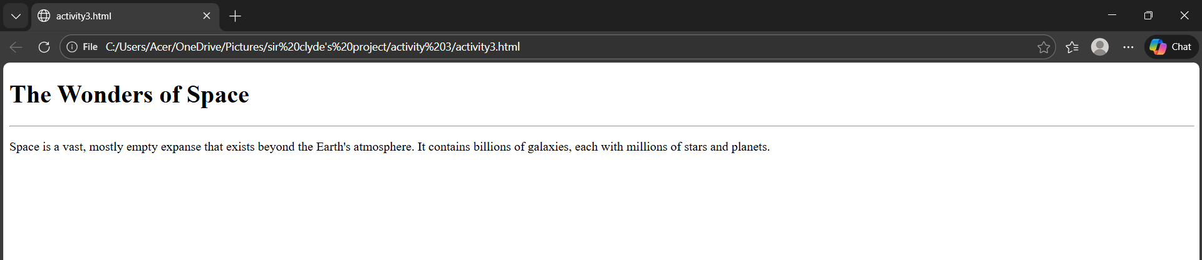

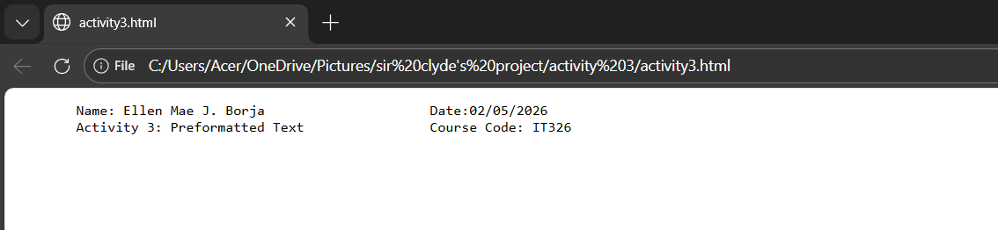
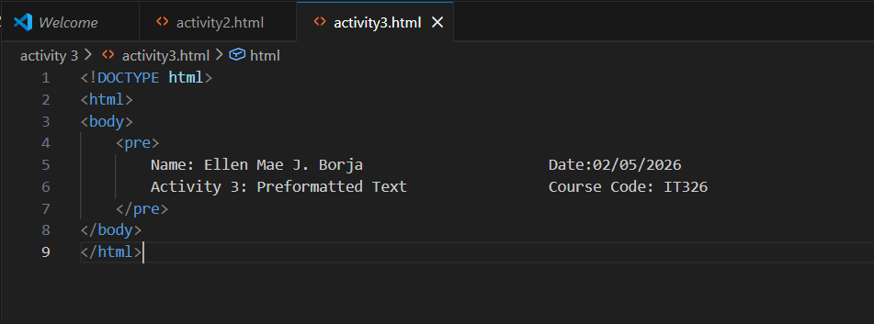
Exercise 6: Print some preformatted text of your choosing.

Exercise 7: Print a long quote and a short quote. Cite the author of each quote.
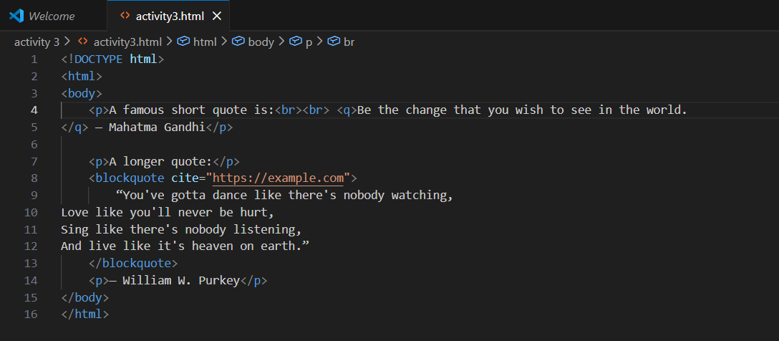

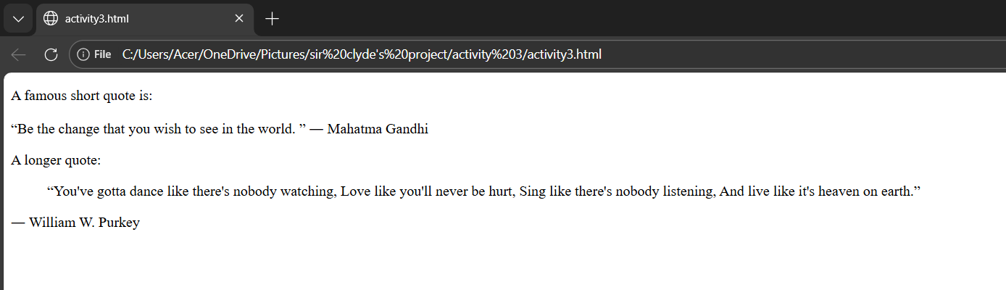

Exercise 8: Print some deleted and inserted text of your choosing.
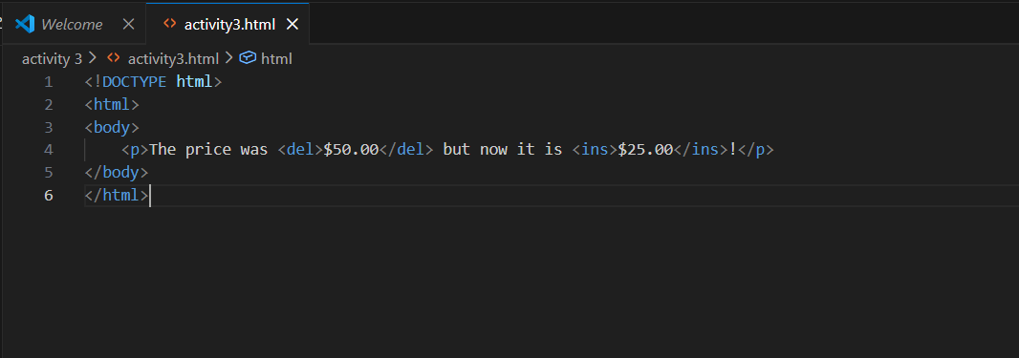

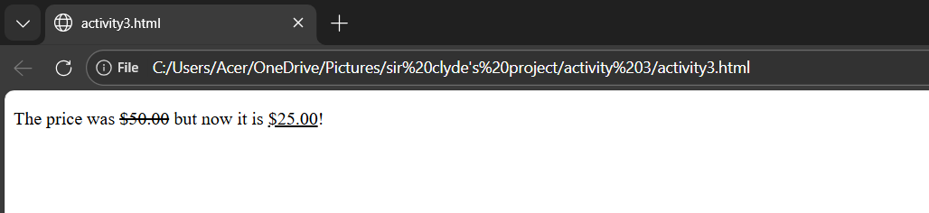

Exercise 9: Print a definition list with 5 items.

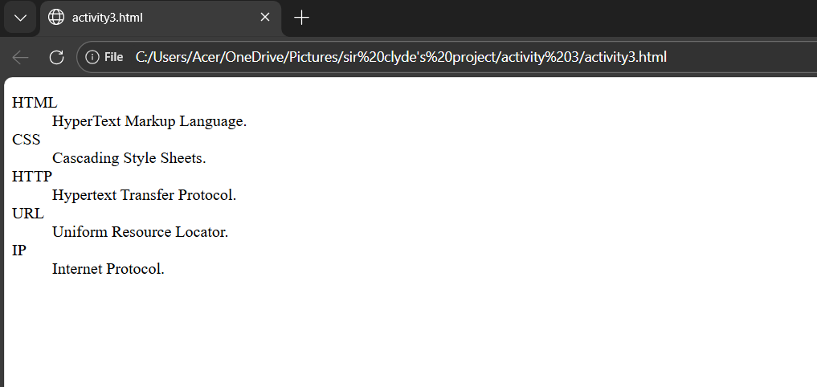
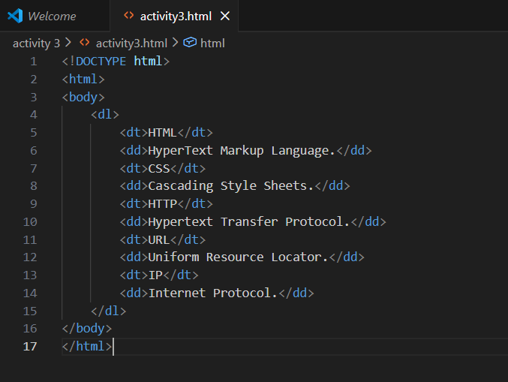

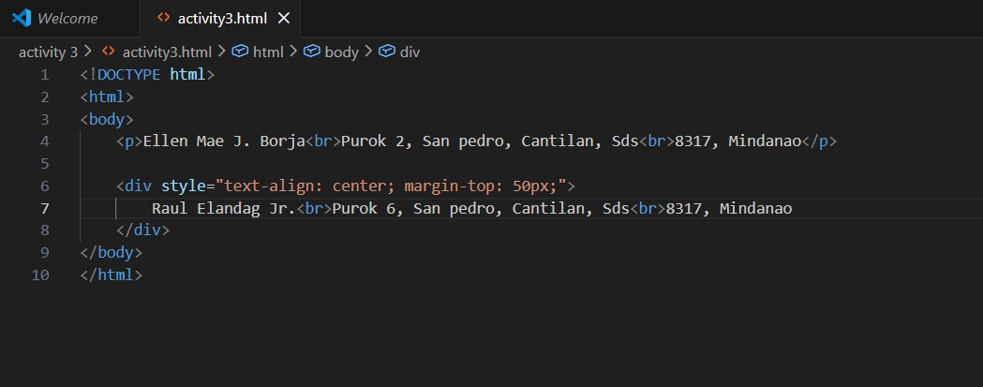
Exercise 10: Print two addresses in the same format used on the front of envelopes.
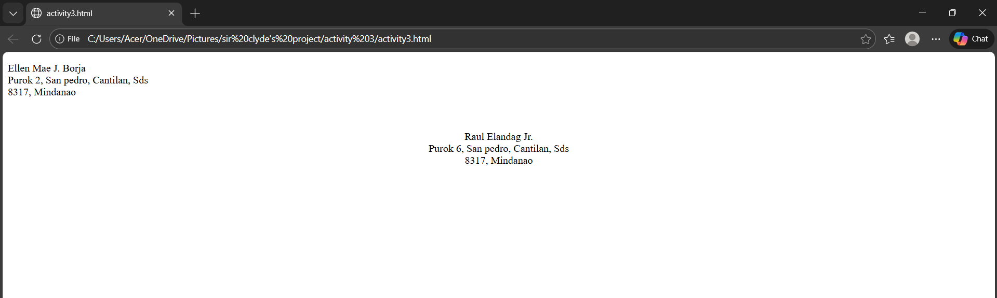

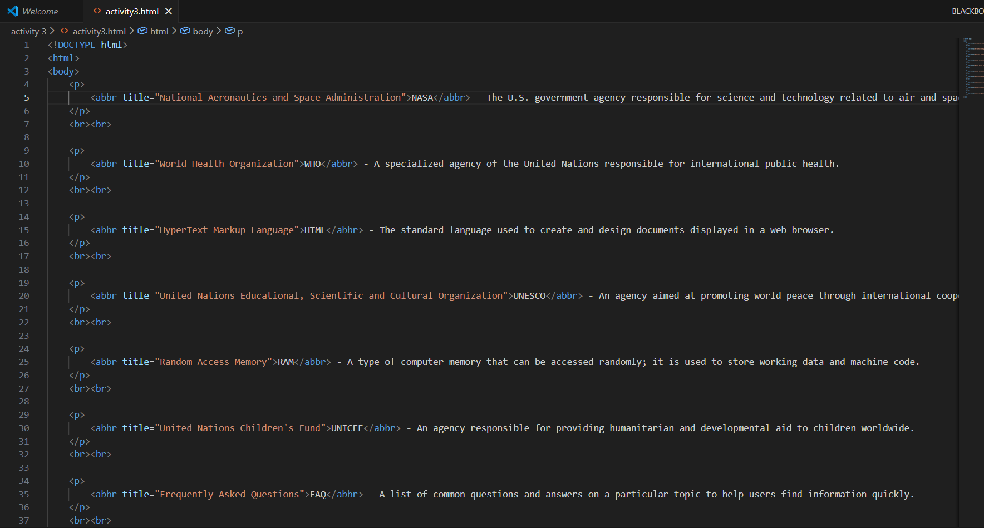
Exercise 11: Print ten acronyms and abbreviation of your choosing. Each separated by two lines. Specify the data that the abbreviation and acronyms represent.
